# MGMT 443 How to test market

* The decision to test market a new product should never be routine
  + Costly
  + Laborious
  + Time consuming
  + The information desired can be obtained more efficiently by product research
* Test marketing may be invaluable for forecasting demand, indicating the probable source and quality of sales
* Basic question
  + Are these tests always necessary?
  + What circumstances led the company to initiate them?
* The relevance of test marketing to an industry depends on the type of manufacturing process involved
* Test markets will be inappropriate in industries where the technology requires the same sort of investment for the production of one unit as for a thousand

## To test or not to test?

* Test marketing two benefits
  + Provides an opportunity to test a product under typical market conditions in order to obtain a measure of its sales performance
  + Provides an opportunity, while the product is on limited sale, for management to identify and correct any weaknesses in either the product or its marketing pan before making the commitment to a national sales launch

### Decision factors

* A test marketing should be used only as a last resort not routine
* Test marketing enables the company to minimize losses but not to maximize profits
* Four major factors
  + Weight the cost and risk of product failure against the profit and probability of success
  + The difference in the scale of investment involved in the test versus national launch route has an important earing on deciding whether to test
  + Likelihood and speed with which the competition will be able to copy your product and pre-empt part of your national market or overseas markets, should the test be successful
  + Take into account the possible damage that a product’s failure can inflict on the company

## New product research

* New product activity and test market performance can only be judged within the total marketing policy and strategy of a particular company and will vary widely between markets and product categories
* Steps
  + Select a sample of respondents according to their claimed buying havits
  + Show respondents the introductory advertising that is planned for the new product and get their reactions to it
  + Show the respondents the product and get their pre-trial reactions to it
  + Give the respondents five samples of the product test at home
  + Conduct an in-home interview to ascertain respondents’ post-trial opinions of the product, recall of the advertisement, and claimed intended frequency purchase
* Tool to further reduce uncertainty
  + Model test market
    - A stage of research inter-posed between pretest research and a full test market
    - Simulate the appropriate marketplace in an attempt to reduce both the time necessary to properly evaluate a full test market and the expense involved
    - Useful in situation where research results have been inconclusive, to set up even a test market, or where a speedy evaluation of a product’s potential is necessary
    - 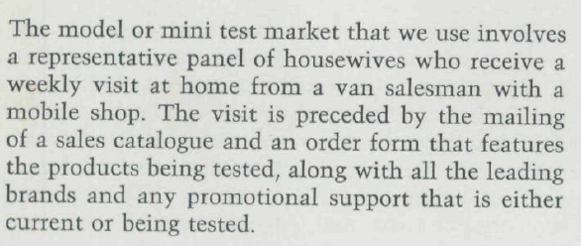

### Limited capabilities

* Factors that affect the research
  + The market in which the new product operates has to be artificially defined and limited
  + The respondents are acting under enforced 100% trial and repeat trial
  + The time factor is artificial, so that management either selects only heavy users of product or enforces artificially heavy consumption upon lighter users
* Research can indicate the acceptability of recipe, package design, name, price, size, and advertising
  + Cannot take the place of a test market when trying to assess the frequency of purchase, novelty value, and extent to which the new product will substitute for sales of existing company products
* The more unusual or novel the new product, the more difficult it is to assess its future prospects at the research stage
* The only accurate way of assessing substitution is through a test market

## Measuring test performance

* Management also has to know the nature of the sale
* The source of sale is important in indicating the future level of settled-down sale

## Selection of test region

* Care must be taken to avoid distortions in test market results
* The test area must be of the same weight as could be afforded on a national basis

## Length of test run

* Depends on the length of time it takes to judge the product’s performance against the company’s objectives for it
* The reader can see that at least for the first six months there is no appreciable difference in the relative levels of distribution achieved, but thereafter distribution of the unsuccessful product begins to tail off
* While some clear success and failure can be identified sooner, we place little weight on test market results achieved during the first six months
* After that, the pattern of repeat sales begins to establish itself and accurate predictions become possible

## Why products fail

* Overall positioning and advertising